# KATVR Unity引擎插件使用说明

KATVR Unity engine plug-in instructions

-2022.03.23

1. **使用前检查 Check before use**
2. Walk以及Walk 豪华版用户，请确认收到并连接好行业应用版本的底部传感器和脚步接收器（有线版本仅有底部传感器）、行业应用版本的Runtime、对应Runtime编号的加密狗以及SDK插件，并确认传感器的USB线已经正确连接电脑，建议使用USB3.0及以上的接口；

For Walk and Walk Premium users, please confirm that you have received and connected the bottom sensor and foot receiver of the industry application version (the wired version only has the bottom sensor), the runtime of the industry application version, the dongle corresponding to the Runtime number, and the SDK plug-in , And confirm that the USB cable of the sensor has been correctly connected to the computer. It is recommended to use USB3.0 and above ports.

1. 打开Runtime程序，确认数据正常且会变化。

备注：如果不需要实机测试，可以使用Testruntime进行测试。

Open the Runtime program and confirm that the data is normal and subject to change.

Note: If you don't need real machine testing, you can use Test-runtime to test.

1. **插件使用 Plug-in use**
2. 打开SDK压缩包，获取并导入Unity工程文件中；

Open the SDK zip package, obtain and import into the Unity project file

1. 将KATDevice.cs脚本附加在任意场景物体中，或者直接使用；

Attach the KATDevice.cs script to any scene object, or use it directly;

1. 也可以直接对预制体进行修改。

You can also modify the prefab directly.

1. 关于震动模块的引用

References to the vibration module

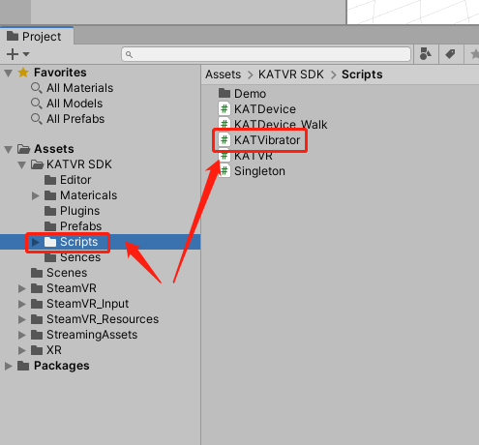

[DllImport("WalkerBase", CallingConvention = CallingConvention.Cdecl)]

public extern static bool Haptic_Module_Control(int haptic_level, int haptic_time)

// Control vibration module: prioritise new commands

//[haptic_level] Vibration level: 0-5

//[haptic_time] duration of vibration: 0-3000 [unit: 100ms]

//return value.

//True: command sent successfully

//False: not started successfully, command sending failed

[DllImport("WalkerBase", CallingConvention = CallingConvention.Cdecl)]

public extern static bool Haptic_Module_Control(int haptic_level, int haptic_time)

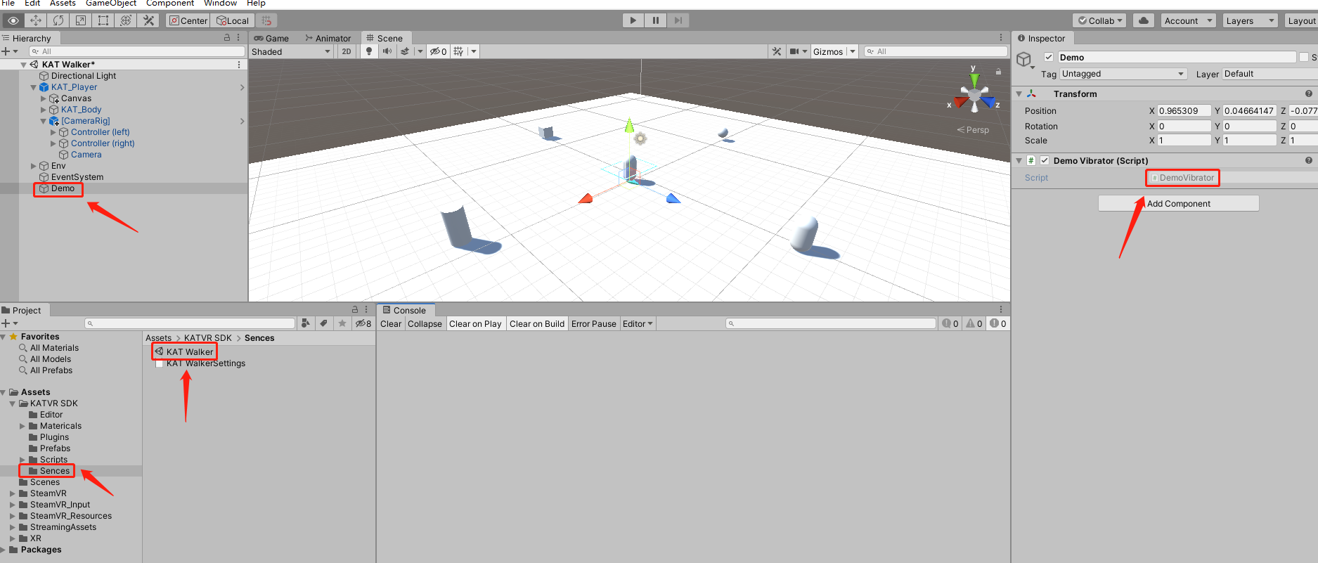

SDK中KAT Walker中包含一个Demo用来测试震动模块是否调用，测试键盘按键为K（或者手柄扳机键）,震动等级为5级，时间为100s，时间可以自行调整。

A demo is included in the KAT Walker SDK to test whether the vibration module is called, with a keyboard button of K (or the joystick trigger button), a vibration level of 5 and a time of 100s, which can be adjusted by yourself.

1. **参数说明parameter description**

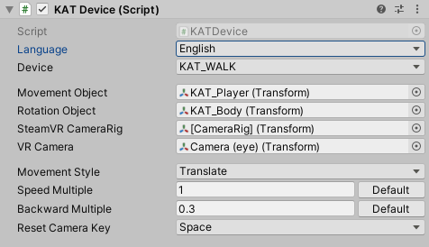

**语言设置：**选择插件在Inspector面板上的显示语言；

Language setting: select the display language of the plug-in on the Inspector panel;

**使用设备：**选择该物体使用的KATVR硬件类型；

Device: select the KATVR hardware type used by the object;

**目标移动物体：**选择需要控制移动的目标物体，通常为玩家角色需要移动的物体；

Movement object: Select the target object that needs to be controlled to move, usually the object that the player character needs to move;

**目标旋转物体：**选择需要控制旋转的目标物体，通常为玩家角色需要旋转的物体，目标旋转和目标移动物体可以设置为一个，也可参考插件内默认的Prefab物体关系；

Rotation object: Select the target object that needs to be rotated, usually the object that the player character needs to rotate. The target rotation and the target moving object can be set as one, or you can refer to the default Prefab object relationship in the plug-in

**SteamVR预制体：**选择主角的SteamVR的CameraRig物体；

SteamVR CameraRig: select the main character's SteamVR CameraRig object;

**VR主相机：**选择上面CameraRig物体下面的Camera（eye）物体；

VR Camera: select the Camera (eye) object below the CameraRig object above;

**移动方式：**可以选择普通的Translate位移和通过改变RigidBody的velocity的方式去移动，开发者也可以去自定义一些移动方式；

Movement Style: You can choose ordinary Translate displacement and move by changing the velocity of RigidBody, and developers can also customize some movement methods;

**速度倍率：**通过此参数去调整玩家的前进和后退时的行走速度，点击按钮恢复默认值；（此处建议使用默认值前进和后退的倍率均为1，或者等比例放大缩小）

Speed Multiple: Use this parameter to adjust the player's walking speed when moving forward and backward, and click the button to restore the default value; ( it is recommended to use the default value for forward and backward magnifications to be 1, or to zoom in and out in equal proportions)

**相机重置键：**该键位是防止当玩家在游戏过程中出现行走方向不正常时使用的矫正按键，推荐在游戏发布时将此按键放置到方便玩家的使用的位置，比如手柄上的application按键。

Reset Camera Key : This button is to prevent the player from using the corrective button when the walking direction is abnormal during the game. It is recommended to place this button in a convenient location for the player when the game is released, such as the application button on the handle .

1. **打包发布 release**
2. 项目发布时，请选择以64位版本方式发布；
3. When the project is released, please choose to release it in a 64-bit version;
4. 项目发布后确认在游戏的_Data文件夹内的Plugins目录下存有WalkBase.dll文件。

. After the project is released, confirm that there is a WalkBase.dll file in the Plugins directory in the _Data folder of the game.

1. **场景测试 scene test**
2. SDK中包含一个测试用Demo场景可以测试传感器数据是否正常；

. The SDK includes a demo scene for testing to test whether the sensor data is normal;

1. 打包好的场景可以用Testruntime进行简单测试，没问题之后在用Developruntime进行测试。
2. The packaged scene can be simply tested with Test-runtime, and after no problem, use Developruntime to test.

备注：SDK包中包含有Testruntime和Developruntime的使用说明。

Note: The SDK package contains instructions for using Testruntime and Developruntime.